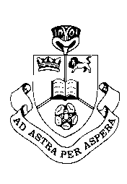
RBHS
Science
Year 10 TOPIC TEST - Electricity
Credits: 2
Year: 2014
Strand: Mixed
Time: 50 minutes

Name: Class: Teacher:
Achieved |  | Achieved with Merit |  | Achieved with Excellence
 |  | Final Grade

QUESTION ONE – Static Electricity

Assessor’s use only

(A)

(M)

(A)

(A)

Static electricity can be described as the build up of charge. Balloons are often used to demonstrate this.

  - Describe how a balloon can become negatively charged.
____________________________________________________________________________________________________________________________________________________________________________________________________________

  - The balloon can stay negatively charged to quite a long time. What property allows the balloon to stay charged?
______________________________________________________________________________________________________

Some other balloons were given positive and negative charges.

  - State whether the following balloons will attract or repel each other
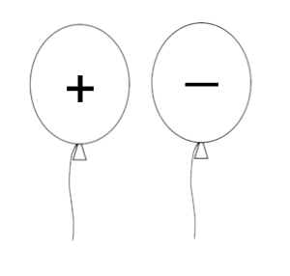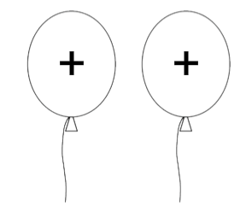

_________________ ________________

Assessor’s use only

(A)

(M)

(A)

(A)

Assessor’s use only

(A)

(M)

(E)

(A)

(M)

(E)
The picture shows a young girl touching a Van der Graph generator while standing on a block of polystyrene.

  - Discuss why the girls’ hair stands on end. Assume that the dome is negatively charged. In your answer include
- the movement of charges
- why the polystyrene is needed
_____________________________________________________________________________________________________________________________________________________________________________________________________________________________________________________________________________________________________________________________________________________________________

When refuelling aircraft, the plane must be connected by a wire to the ground.
  - Discuss why this wire is needed and what could happen if the wire was not connected
_______________________________________________________________________________________________________________________________________________________________________________________________________________________________________________________________
___________________________________________________
QUESTION TWO – Basic Circuits

Assessor’s use only

(A)

(A)

- Write the correct name beside the symbols used in basic electrical circuits.
Ammeter, Battery, Cell, Fuse, Lamp, Resistor, Switch, Voltmeter
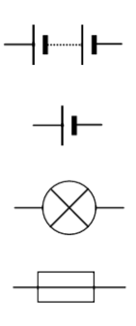 | _____________  _____________  _____________  _____________ | 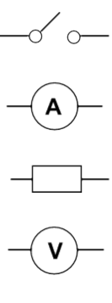 | _____________  _____________  _____________  _____________

The circuit diagram below shows a single bulb connected to a power pack with two meters to measure the current and voltage in the circuit.

- Complete the diagram by Writing A and V in the correct meter.

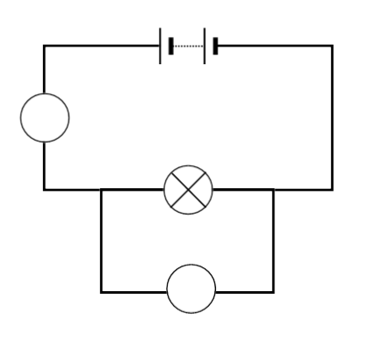

After setting up the circuit the meters showed the following values.

Assessor’s use only

(A)

(A)

(M)

(E)
- Record the value and the unit of both the ammeter and the voltmeter.

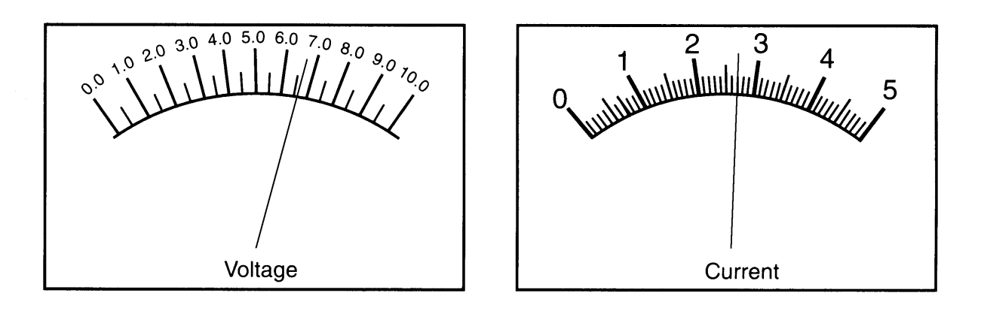
Value: _____________  Unit: ______________ | Value: _____________  Unit: ______________

Two students were having a disagreement about what components were resistors. John thought that a lamp was not a resistor while Whetu thought that it was.
- Decide which student is correct by looking at both the similarities and differences between a lamp and a resistor. In your answer include:
  - the function or purpose of both components
  - how the components affect the current
  - how the components affect the voltage
________________________________________________________________________________________________________________________________________________________________________________________________________________________________________________________________________________________________________________________________________________________________________________________________________________________________________________________________________________________________________________________________________
QUESTION THREE – Series Circuits

Assessor’s use only

(A)

(A)

(A)

(A)

(M)

(E)

(A)

(M)

(E)

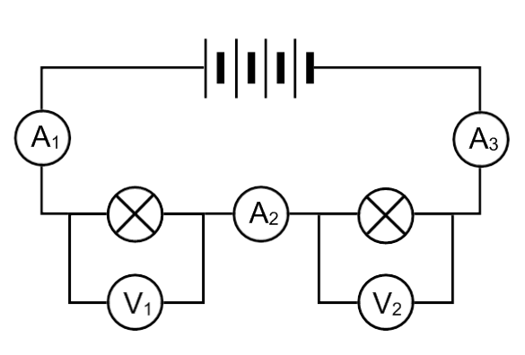

Two identical lamps are connected in series with a battery made up of four 1.5V cells.

- What is the Voltage supplied to the circuit by the battery?
_____________________________________________________

- If the current at A₁ is 0.4 amps what is the current at A₂ and A₃?
A₂ = _____________ A₃ = ________________

- What is the voltage across each lamp?
V₁ = _____________ V₂ = ________________

- Describe what will happen to the brightness of the lamps if another lamp is added in series. You should explain your answer by discussing (with reasons) what happens to the voltage and the current.
_____________________________________________________________________________________________________________________________________________________________________________________________________________________________________________________________________________________________________________________________________________________________________________________________________________________________________________________________________________________________

Assessor’s use only

(A)

(A)

(A)

(A)

(M)

(E)

(A)

(M)

(E)

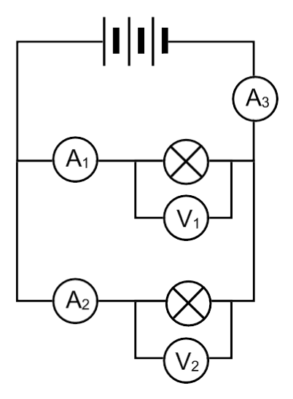
QUESTION FOUR – Parallel Circuits

Assessor’s use only

(A)

(M)

(A)

(M)

(A)

(A)

(M)

(E)

(A)

(M)

(E)

Two identical lamps are connected in parallel with a battery made up of three 1.5V cells.

- What is the voltage across each lamp
V₁ = ________________
V₂ = ________________

- If the current at A₁ is 0.8 amps what is the current at A₂ and A₃?
A₂ = _____________ A₃ = ________________

- Describe what happens to the brightness of the lamps if another lamp is added in parallel.

__________________________________________________________________________________________________________

- Car head lights and house lights are wired in parallel (rather than in series). Discuss the main reason that these lights are wired in parallel.

________________________________________________________________________________________________________________________________________________________________________________________________________________________________________________________________________________________________________________________________________________________________________________________________________________________________________
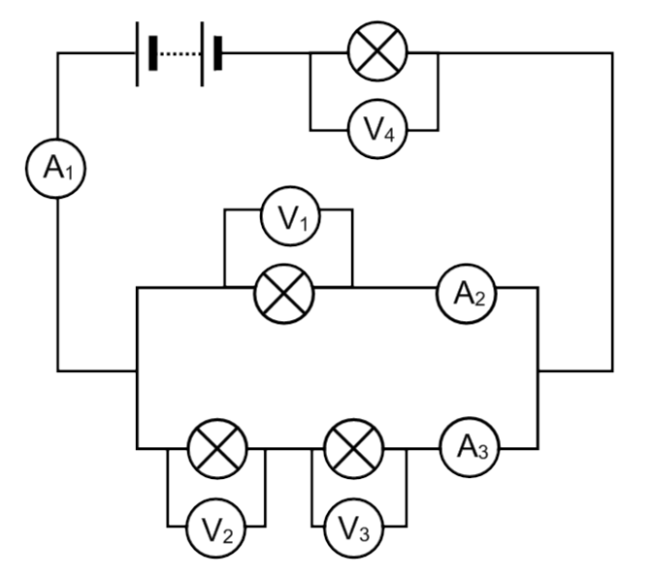
QUESTION FIVE – Combination Circuits

Assessor’s use only

(A)

(M)

(E)

(A)

(M)

(E)

(A)

(M)

(E)

Assume that all lamps are identical

- if V₂ is 4V and V₄ is 7V what is the voltage supplied by the power pack

(Show your working and the values of other voltmeters)

______________________________________________________________________________________________________________________________________________________________________________________________________________________________________________________________________________________________________________________________
Voltage of power pack = ________________

- The reading on A1 is 3A.
  - what would the readings on A2 and A3 be?
A₂ = ____________
A₃ = ____________

  - Explain how you decided the values for A2 and A3
_________________________________________________________________________________________________________________________________________________________________________________________________________________________________________________________________________

Ideas for other questions
Static
  - electroscope
  - Discuss how a balloon is able to pick up a small piece of paper.

