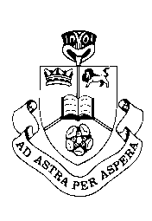
RBHS
Science
Year 10 – The Structure of Matter
Credits: 2
Year: 2014
Strand: Mixed
Time: 50 minutes

Name: Class: Teacher:
Achieved |  | Achieved with Merit |  | Achieved with Excellence
 |  | Final Grade

QUESTION ONE

Assessor’s use only

(A)

(A)

(M)

(E)

  - Give the word that best describes the following types of matter
Atom, compound, crystal, element, mixture, stucture
Matter that only contains one type of atom | ____________
Two or more different types of atoms that are chemically joined together. | ____________
Two or more elements and/or compounds that are not joined together. | ____________

  - Describe how liquids and gases are able to take the shape of their containers, but solids cannot.
Your answer should consider
- drawing a diagram
- the spacing and arrangement of the particles
- the movement of the particles

______________________________________________________________________________________________________________________________________________________________________________________________________________________________________________________________________________________________________________________________________________________________________________________________________________________________________________________________________________________________________________________________
QUESTION TWO

Assessor’s use only

(A)

(M)

(A)

(A)

(M)

- A Lithium atom can be represented by the diagram below.
Correctly label the parts of the atom.
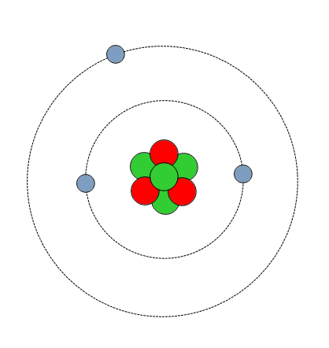
b)
a)

c)

- What charges do the parts above have?

a)________________________

b)________________________

c)________________________

- Complete the following table

Symbol | Atomic  number | Mass  number | Number  of protons | Number of electrons | Number of neutrons
Al | 13 | 27 | 13
C |  | 12 |  | 6 | 6
Na | 11 | 23 | 11 |  | 12
O | 8 | 16 |  | 8 | 8

QUESTION THREE

Assessor’s use only

(A)

(M)

(A)

(M)

(E)

(A)

(M)

(E)

- state how an atom can become an ion
__________________________________________________________________________________________________________

- complete the following table
Symbol | Name | Number of electrons | Electron arrangement | Does it lose or gain electrons to become an ion? | Number of electrons lost or gained | Ion Symbol
Na | sodium | 11 |  |  |  | Na⁺
N | nitrogen |  | 2,5 | Gain
Al | aluminium |  | 2,8,3
S | sulfur | 16

- Discuss the similarities between Li, Na and K atoms in terms of their position in the periodic table, their electron arrangements and the ions they form.

- Explain why the noble gases He, Ne and Ar do not lose or gain electrons and why they are sometimes called inert gases.

Assessor’s use only

(A)

(M)

(A)

(M)

(A)

(M)

(E)

- Name the following compounds:
eg PbF₂ lead fluoride
- NaCl ________________________________
- KOH ________________________________
- H₂S ________________________________
- CuSO₄ ________________________________
- AgNO₃ ________________________________

- Complete the table to find the formula for the following compounds:

 | name of compound | positive ion | negative ion | formula
eg | hydrogen oxide | H⁺ | O²⁻ | H₂O
(i) | magnesium oxide
(ii) | aluminium chloride
(iii) | sodium hydrogen carbonate
(iv) | calcium carbonate
(v) | lithium oxide

QUESTION FOUR

Assessor’s use only

(A)

(A)

(M)

(E)

  - Write a ‘P’ or a ‘C’ to show if a physical or chemical change is taking place.
____ | glass breaking | ____ | burning leaves
____ | a rusting bicycle | ____ | fireworks exploding
____ | bleaching your hair | ____ | crushing a can
____ | mixing salt and water | ____ | boiling water

  - Discuss the difference between a chemical and a physical change

Your answer should consider
- what you would observe in each
- whether you can undo the change
- how atoms are arranged before and after the change

_______________________________________________________________________________________________________________________________________________________________________________________________________________________________________________________________________________________________________________________________________________________________________________________________________________________________________________________________________________________________________________
_____________________________________________________________________________________________________________________________________________________________________
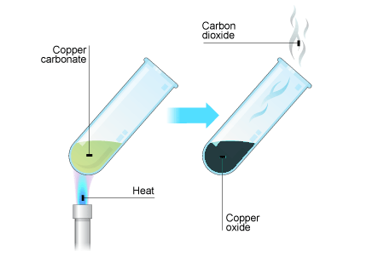
QUESTION FIVE

Assessor’s use only

(A)

(M)

(A)

(M)

(E)

  - When copper carbonate (a green powder) is heated, it changes colour to black copper oxide and carbon dioxide gas is given off.

Write the word equation for this reaction in the box below:
→

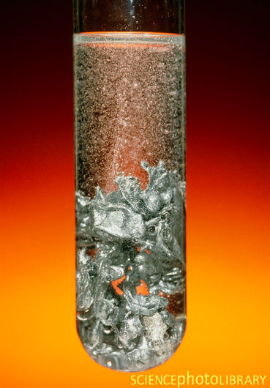
  - When zinc metal is placed in hydrochloric acid (HCl) hydrogen gas is given off and the zinc disappears to give a colourless solution of zinc chloride.

Write the word equation for this reaction in the box below:
→

Write the chemical equation for this reaction in the box below:
→

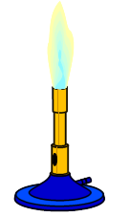
  - When a Bunsen burner is lit the methane fuel (CH₄) reacts with oxygen in the air to make carbon dioxide and water.

Assessor’s use only

(A)

(M)

Write the word equation for this reaction in the box below:
→

Table of ions
+1 | +2 | +3 | -2 | -1
H+ | Mg²⁺ | Al³⁺ | O²⁻ | Cl-
Li⁺ | Ca²⁺ |  | S²⁻ | OH-
Na⁺ | Cu²⁺ |  | CO₃²⁻ | NO3-
K⁺ | Zn²⁺ |  | SO₄²⁻ | HCO₃⁻
Ag⁺ | Pb²⁺

He
2
4
Helium

Ne
10
20
Neon

Ar
18
40
Argon

H
1
1
Hydrogen

Li
3
7
Lithium

Na
11
23
Sodium

Be
4
9
Beryllium

Mg
12
24
Magnesium

B
5
11
Boron

Al
13
27
Aluminium

C
6
12
Carbon

Si
14
28
Silicon

N
7
14
Nitrogen

P
15
31
Phosphorus

O
8
16
Oxygen

S
16
32
Sulfur

F
9
19
Fluorine

Cl
17
35
Chlorine

K
19
39
Potassium

Ca
20
40
Calcium

