Assessment schedule for Year 10 Science assessment on FORCES AND MOTION Mainstream 2011

 | Criteria |  | A | M | E
1.(a) | contact forces non-contact forces  drag force friction force thrust force support force gravitational force magnetic force electrostatic force |  | All correct
(b) | Slow down/change direction/change shape |  | 2/3 correct
(c) | on Earth in space on the Moon  mass 90 kg 90 kg 90 kg  weight 900 N 0 N 144 N  mass is the amount of “stuff” inside you this does not change no matter where you are so the mass of the astronaut is always 90kg  weight is how much force you exert on the ground which is caused by gravity/gravitational field pulling on you mass.  On earth the gravitational field strength is 10 so the weight force of the astronaut is 900 N, in space the gravitational field strength is (almost) 0 so the astronaut is “weightless”, and on the moon gravitational field strength is 1/6th of on earth (g = 1.6) so the weight of the astronaut is 144 N. |  | mass is 90 kg | mass is 90 kg  and  correct weights  or  definitions | mass is 90 kg  and  correct weights  and  definitions
2.(a) | 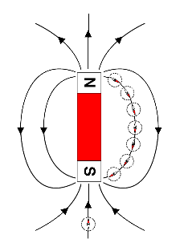 |  | field lines | field lines with arrows
(b) | accelerate away from each other (accept move apart, repel) |  | correct answer
(c) | paper clip, iron nail, stainless steel spoon |  | 2 correct  (or 3 and 1 wrong)
3.(a) | 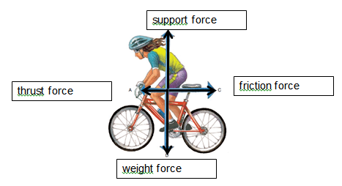 |  | Correct answer
(b) | weight and support |  | Correct answer
(c) | air resistance = friction force |  | Correct answer
(d) | sensible answer e.g.  tight clothing  hunch down  slip stream of another bike |  | one sensible answer
(e) | to go faster as thrust would then be bigger than friction  (or use less energy for the speed that they are travelling as less thrust is required) |  | go faster  or  use less energy | justified answer
(f) | the cyclist is slowing down as the friction force is bigger than the thrust force  (there is no acceleration in the vertical direction as the forces are balance) |  | slowing down | slowing down  friction > thrust | slowing down  friction > thrust  considers vertical
4.(a) | 1 Object is not moving  3 Object has a constant speed of 0.375 metres per second  2 Object has a constant speed of 0.125 metres per second  4 Object accelerates and then travels at a constant speed  5 Object travels at a constant speed then slows down and stops |  | 3 correct | all correct
(b) | $$v = \frac{d}{t}$$  $$v = \frac{90}{2.5}$$ | $$v = 36 km/hr$$ | Correct answer
(c) | $$v = \frac{d}{t}$$  $$v = \frac{(90 ×1000)}{(2.5 ×60×60)}$$ | $$v = \frac{90000}{9000}$$  $$v = 10 m/s$$ | Correctly changes  km to m  or  hr to s | Correct answer with working
(d) | $$v = \frac{d}{t}$$  $$13 = \frac{70}{t}$$  $$13 t = 70$$ | $$t = \frac{70}{13}$$  $$t = 5.3846$$  $$t = 5.4 s$$ | Correct substitution into equation  $$13 = \frac{70}{t}$$  or  correct variation of formula selected e.g. $t = \frac{d}{v}$ | formula, substitution and one correct rearrangement. | Correct answer (must show some working)
(e) | 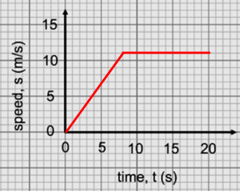 |  | One section correct | Both sections correct
5(a) | The force that occurs between two objects when they come in contact |  | Must mention contact
(b) | Good friction Bad Friction  Traction in cornering Braking Non slip pads etc Engine parts Hulls on water Cars moving through air etc |  | Any four sensible answers
(c) | - Describes how to calculate force. Defines relationship between force mass and acceleration |  | A sensible answer that makes the point
(d) | Symbol its Units  t time Seconds (s)  F Force Newtons (N)  m Mass Kilograms (kg)  a acceleration Metres per second per second (ms⁻²) |  | 4/6 Correct answer | 6/6
(e) | F=ma F= 1kg*10ms⁻² F=10N |  | Correct answer | Correct answer with units and working
(f) | F=ma F/m=ma/m F/m=a a=600N/10kg a=60ms⁻² |  | Correct substitution into equation  $$600 = 10*a$$  or  correct variation of formula selected e.g. $a = \frac{F}{m}$ | formula, substitution and one correct rearrangement. | Correct answer (must show some working)

 | Achievement | Merit | Excellence
Opportunities: | 23 | 11 | 4
Sufficiency: | 12A | 5M + 6 A | 2E + 4M + 6 A

